The Pythagorean Identity Task Sheet
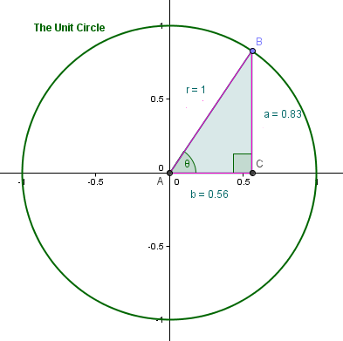
Use the applet named “The Pythagorean Identity Applet” found in My Original Applets on the following website: http://5010.mathed.usu.edu/Fall2012/ADaniels/ to do the following prompts:
- Rotate point B around the unit circle to see the orientation of the triangle in all four quadrants.
- Record lengths of a and b for one triangle in each quadrant (you should have four a's and four b's). Fill in the table.

Quadrant | a | b | a²+b²
I
II
III
IV

- Make a general conjecture about a²+b².

- Make a conjecture about the relationship between a, b, and θ.

- Using your conjecture (and help from the instructor), derive the Pythagorean Identity.

